CAIR MA- Youth Advisory Committee Bios

- Oumayma Dakhama is sixteen years old and a junior at North Andover High School. She is passionate about civil rights and social justice. Her hobbies include baking, reading, and seeing new places. She is very excited to work with CAIR-MA and her fellow advisory committee members to help the Muslim community in Massachusetts.

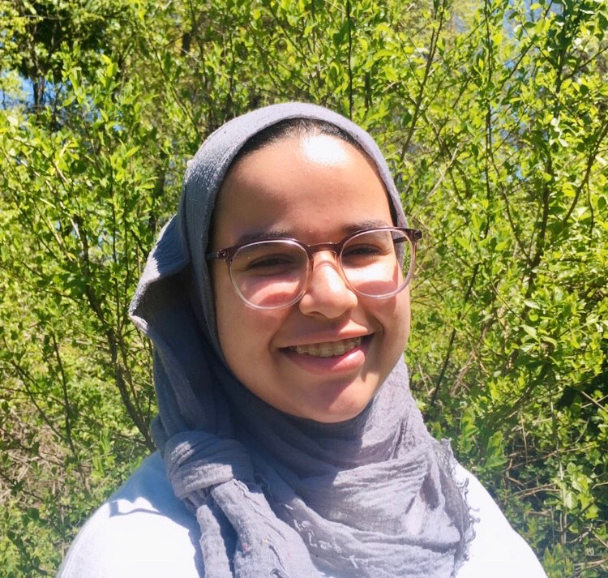

- Mohammad Khan is a junior at Westford Academy. Mohammad's favorite subject is History and loves to learn about the past. He is the Team Captain of the Robotics team at his school and is thinking of going into either Law or Engineering. Mohammad was also part of the first cohort of CAIR-MA's Muslim Youth Leadership Program. His goal over the next year is to help as many Muslim youth as he can through the Advisory Committee.

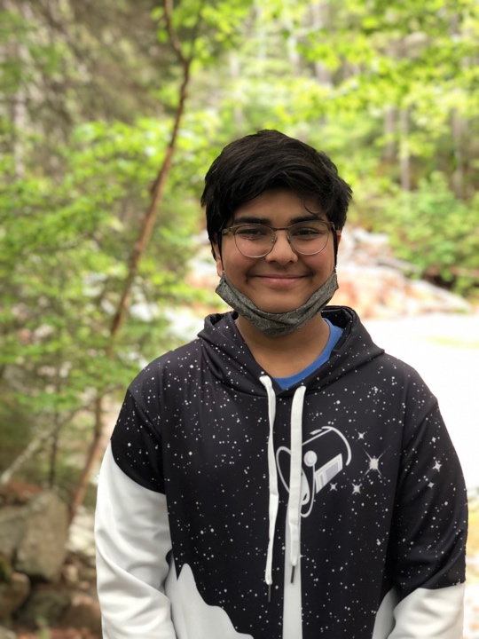

- Mariam Sirage is a junior at Boston Latin School. She is part of her ISBL (Islamic Society of Boston Latin), which is her school's MSA. Mariam is passionate about advocacy work, and believes that working with CAIR is a great way to get some hands-on experience while simultaneously getting involved with her Muslim community. Now having met some of her peers, she's even more excited to be surrounded by a group of motivated, creative, individuals who will help her reach her full potential.
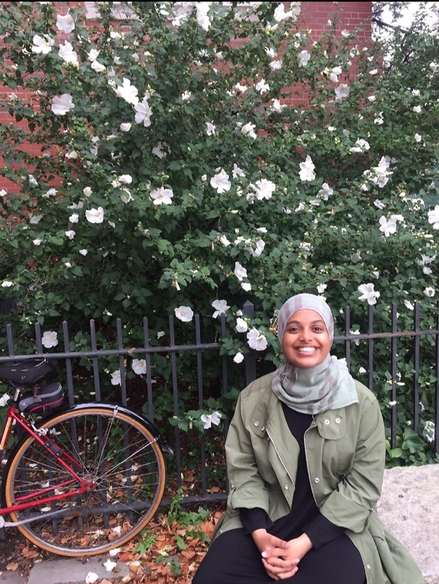

- Suhayla Abdi is super excited to be a part of the first cohort at CAIR-MA! She loves reading, cooking, and listening to her podcast list. Currently, she volunteers at her local masjid, and she helps plan events for the youth. Recently, she hosted an event with sisters about the importance of modesty. Suhayla is heavily involved with the youth, so she believes that joining CAIR-MA will help her continue her love with working and bettering the youth. She is aware that there are injustices towards the Muslim community and that CAIR-MA is here to help educate, support, and uplift. She hopes that during her time here, she can make a change with the team!

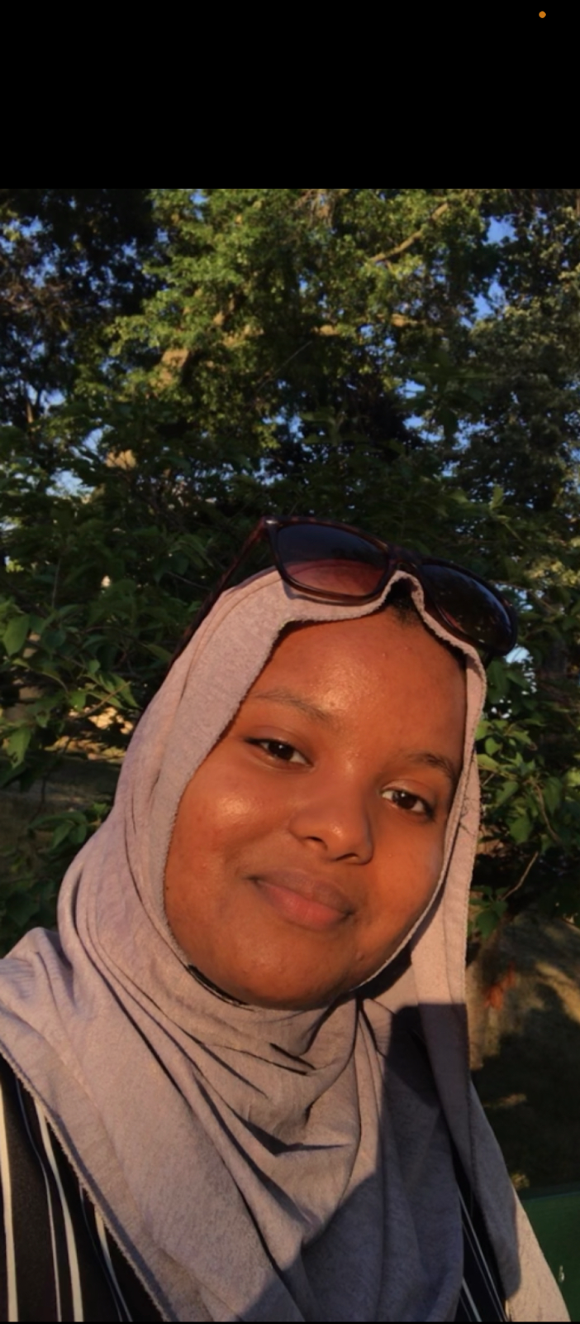

- Amina Naidjate is an Algerian-American senior at Al-Noor Though she is not entirely sure what she wishes to study in college, the fields of Data Analysis, Journalism, and Colonialism Studies intrigue her. She wants to use her skills in public speaking and leadership to serve the political and spiritual needs of the American-Muslim community. If Amina is not in her room lamenting over her homework load, you'll probably find her reading (Harry Potter, of course), scrolling through Google Earth (she highly recommends this), or eating a sandwich.

- Safiyah Bey is a 19-year-old student at Mount Holyoke College and recent graduate of Holyoke Community College where she was President of Student Senate. She has experience working with and leading youth and adults of all races and demographics in areas of food justice, racial justice and interfaith community building.

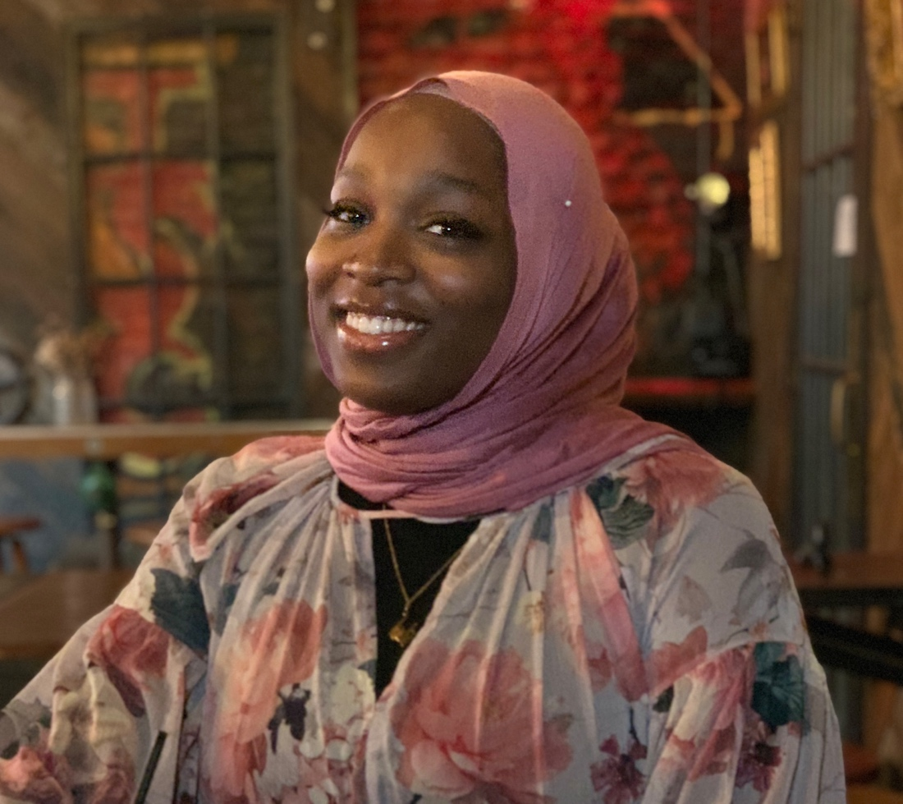

- Jana Amin is a rising freshman at Harvard College. An advocate and community mobilizer for girls’ education and women in Islam, Jana has given a TedX-Youth talk on Muslim women and spoken at the United Nations on policies to further youth inclusion and gender parity. She works closely with The Collateral Repair Project, an NGO based in Jordan to support refugee women and girls. Jana’s research focuses on the media representation of Muslim women. Her mission? Uncover what she knows each girl possesses: a vision and a voice.

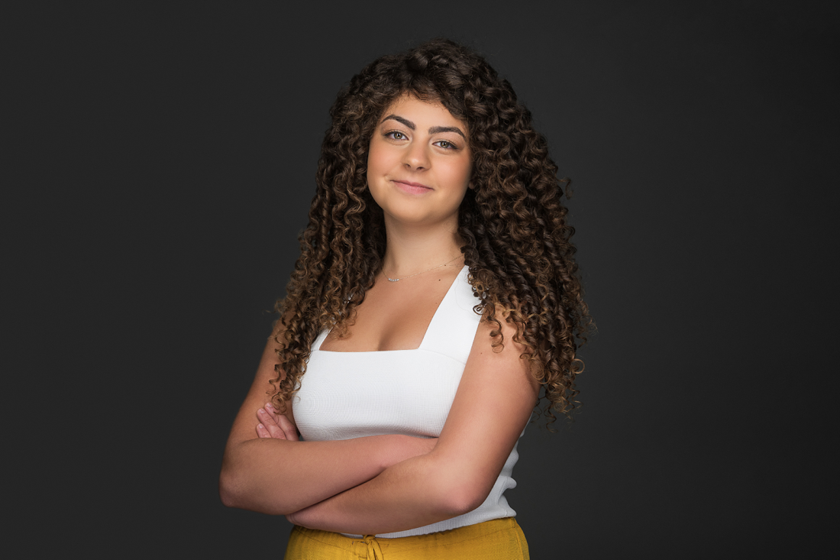

- Zahra is a sophomore at Lexington High School. She is passionate about advocating for equality for Muslims is ready to contribute to the community so that Muslim youth and the general public are aware of the diversity between Muslims vs the image the media displays to represent Muslims. She looks forward to organizing events to bring Muslim youth together and provide a space of comfort and support that they can use to grow, learn about their identity, and gain a stronger voice.

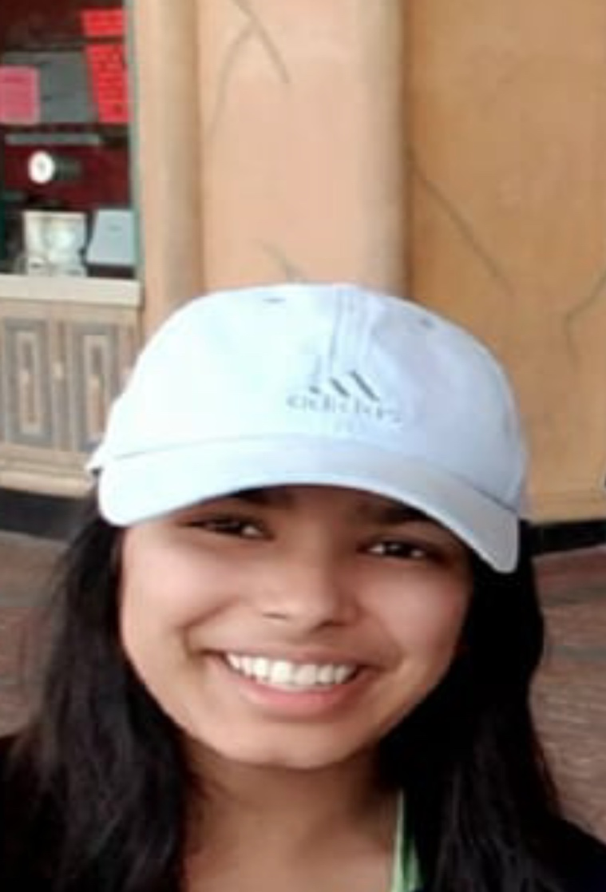

- Ahlam Abdirizak was born in Kenya but is now settled in Burlington, Massachusetts as a current sophomore at Burlington High School. Ahlam serves as the Editor-in-Chief of her school’s newspaper and is involved with local news and journalism. She has a longtime deep passion for poetry that she explores in her MassLEAP poetry youth internship.
Being bilingual in both English as a first language and Somali she learned from her family. She is avid in the discussion around mental health and mental wellness and is eager to learn more. In the future, she plans to continue writing and furthering her education to become a psychiatrist.

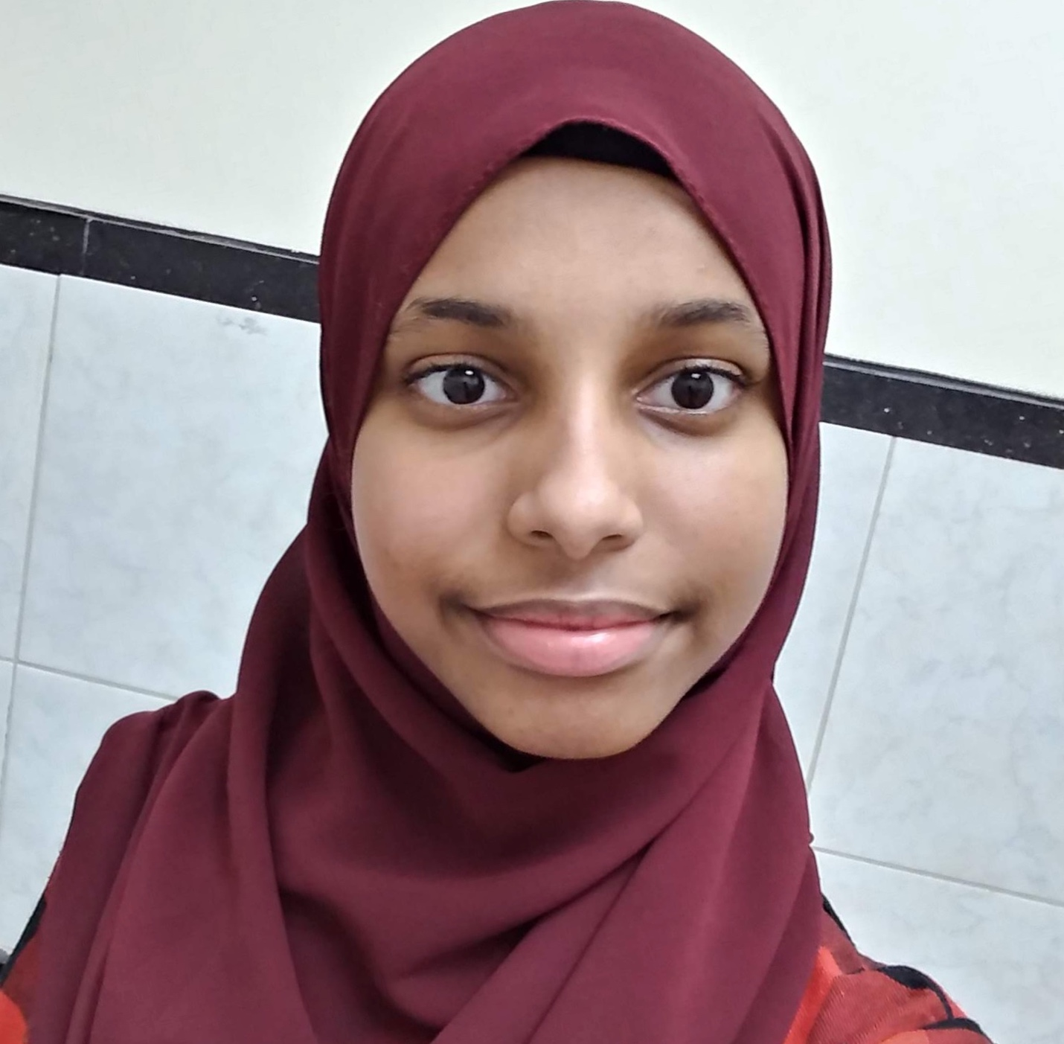

- Ablah Siddiq is a junior from North Andover. She goes to Phillips Academy, and she loves reading, obscure movies, roller skating, and lime seltzer (polarizing opinion, she knows). She's so excited to be a part of the Youth Advisory Committee and help increase civil advocacy in the Muslim community!
